|  |  |
| --- | --- |
| **Ex: No:18** | **ONLINE INTERNSHIP REGISTRATION SYSTEM** |

**USE CASE DIAGRAM:**

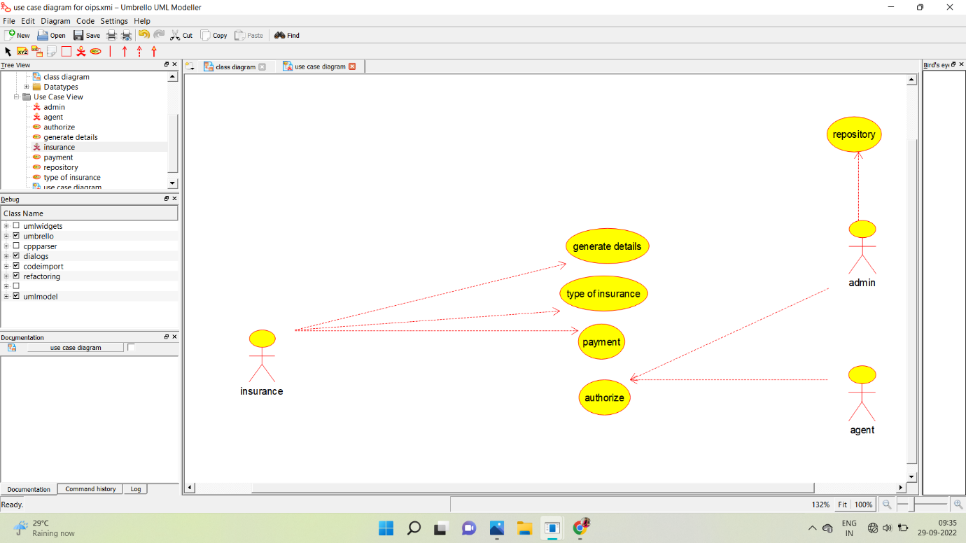

**CLASS DIAGRAM:**

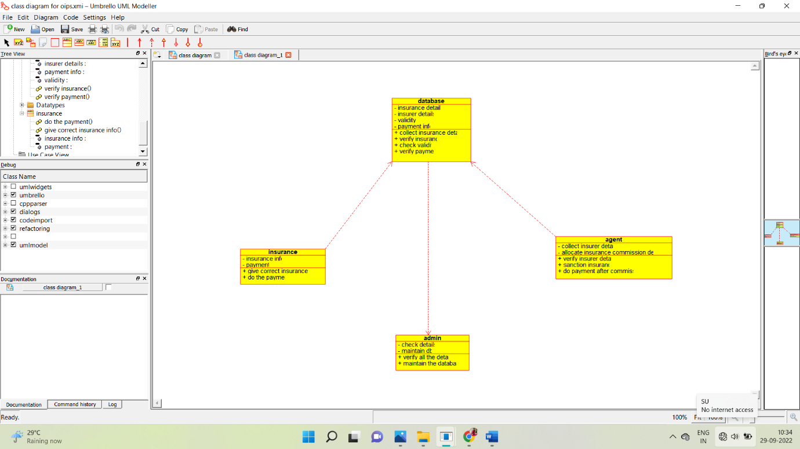

**ACTIVITY DIAGRAM:**

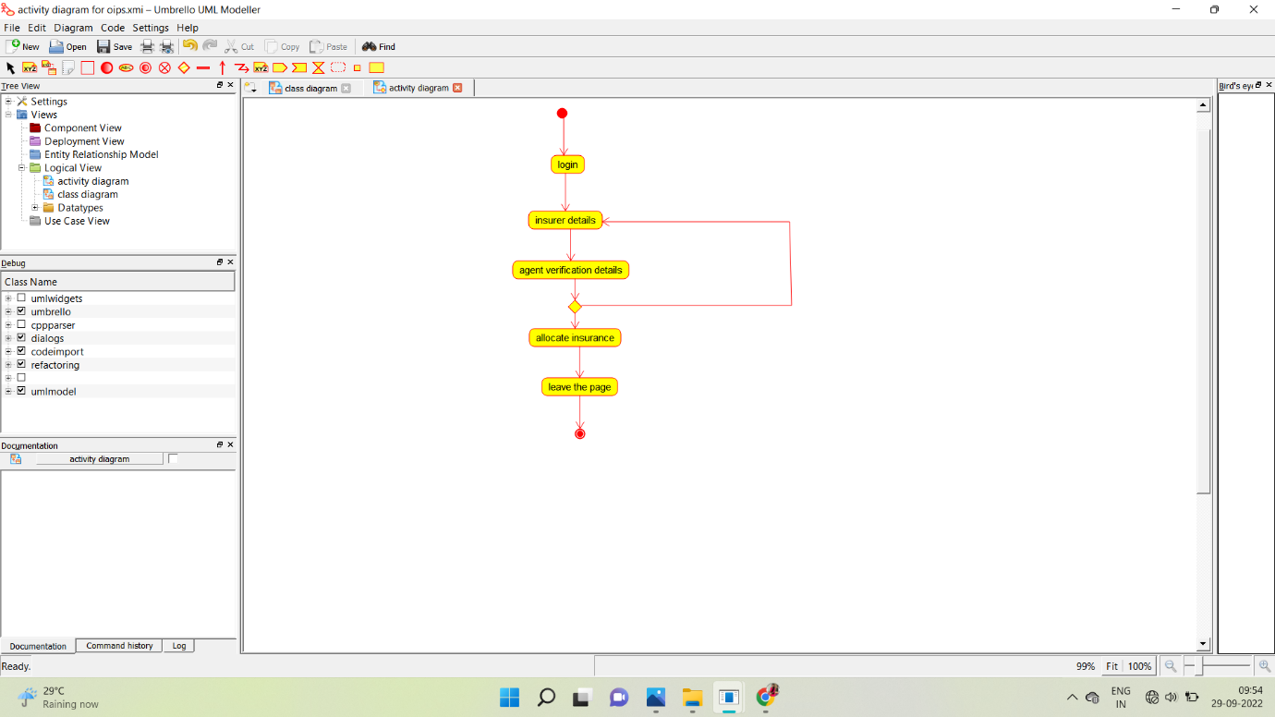

**SEQUENCE DIAGRAM:**

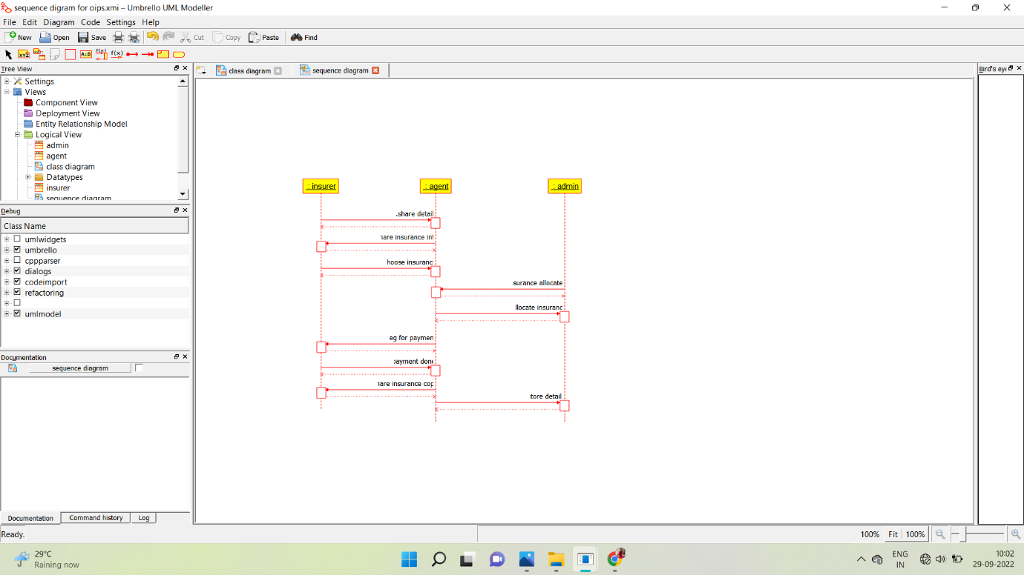

**COLLABORATION DIAGRAM:**

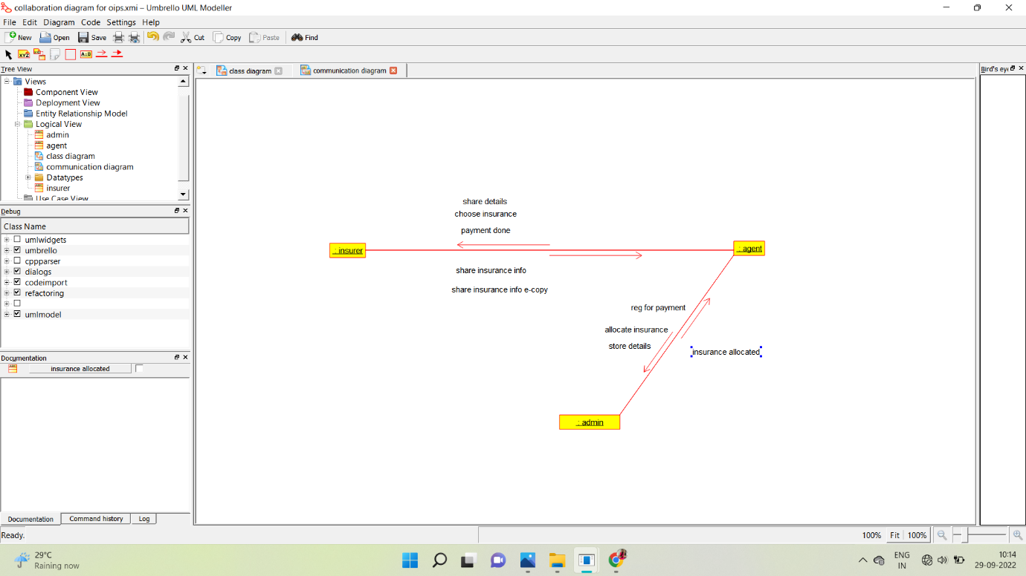

**STATE CHART DIAGRAM:**

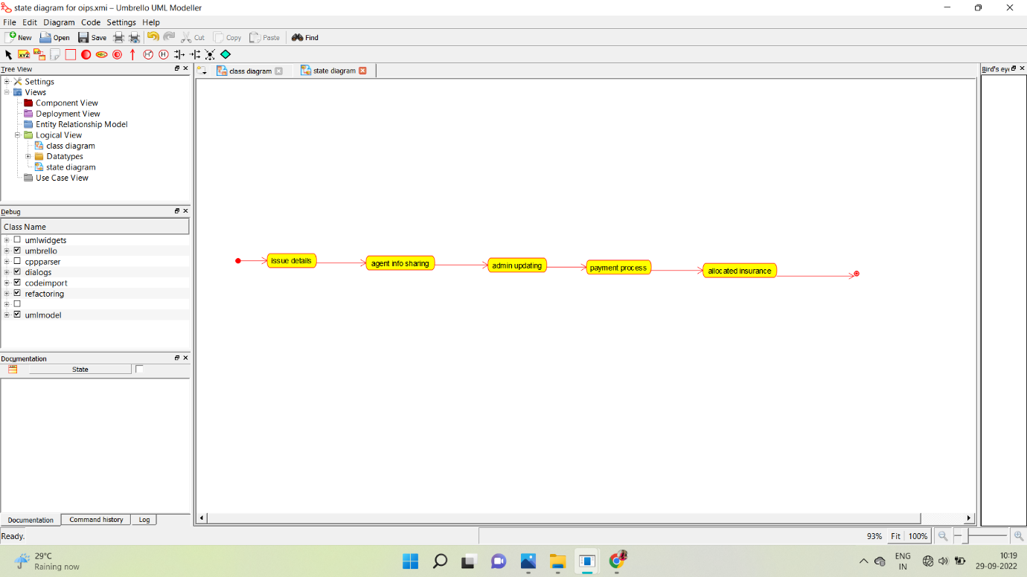

**COMPONENT DIAGRAM:**

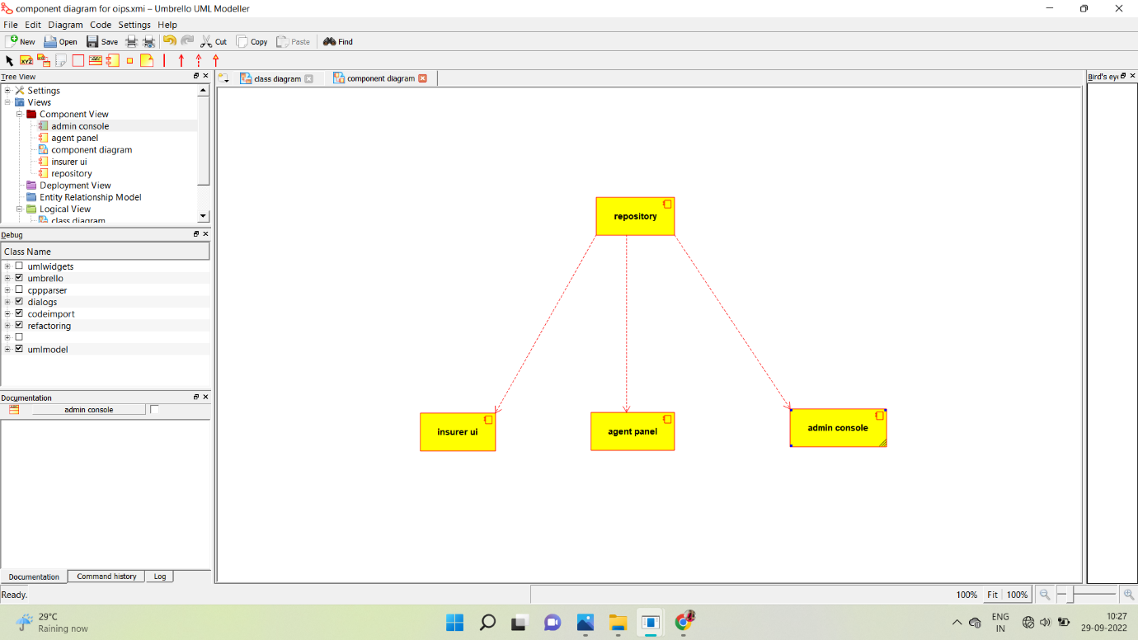

**DEPLOYMENT DIAGRAM:**

